**Address End Point**

**End point :** In simple terms, a web service endpoint is a web address (URL) at which customers of a specific service can gain access to it. By referencing that URL, customers can get to operations provided by that service. The endpoint is a connection point where HTML files or active server pages are exposed.

Steps to create an address end point.

Step 1: Create a new Multi Module Maven project 🡪Create a new ESB layer 🡪 Create a new Rest API.

(Please refer the basic project creation for step 1)

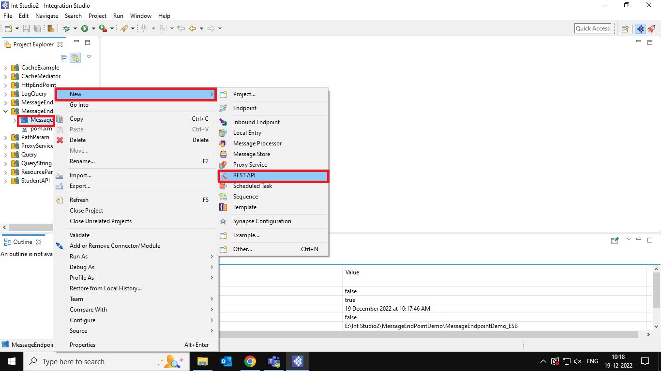

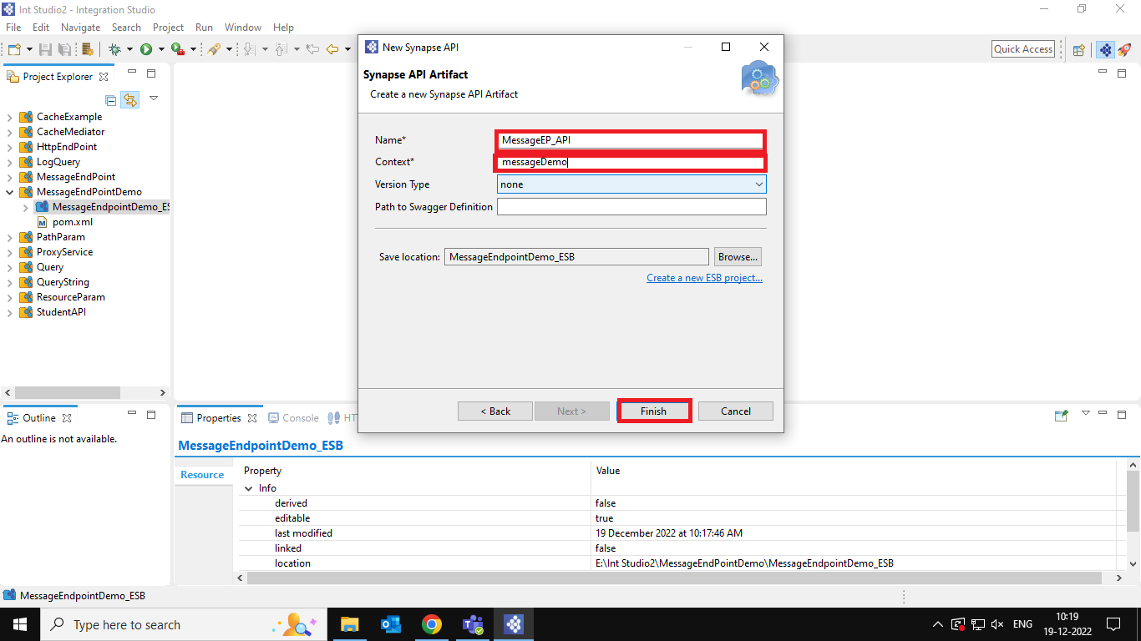

**Step 2:** Click in the API . Then drag the Send mediator in the mediators and drop in the resource as in sequence.

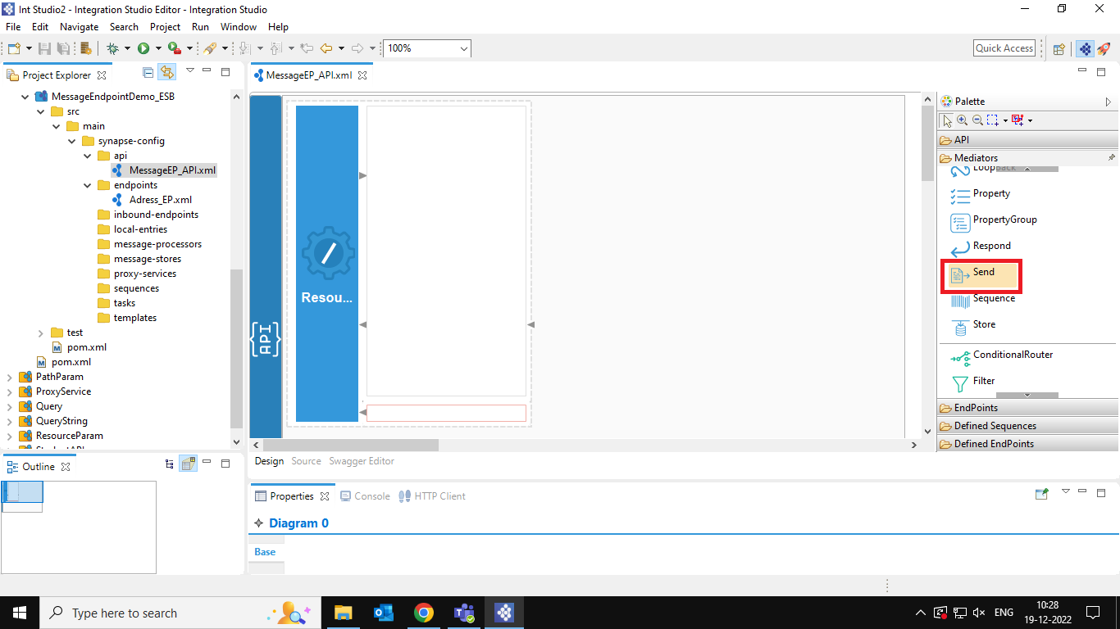

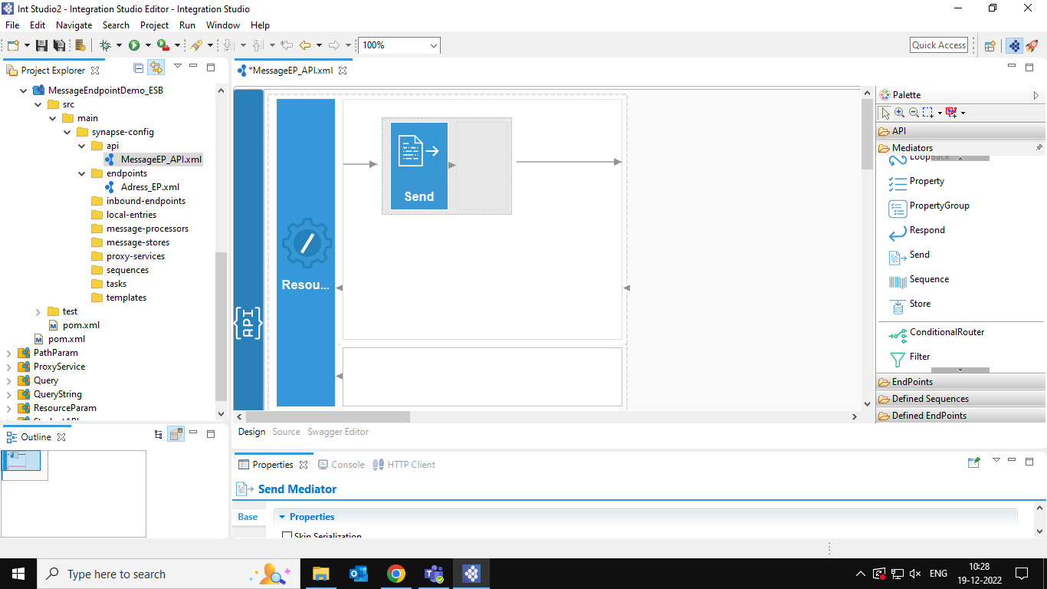

**Step 3:** Create a new End Point . Here we have two methods to define an end point .

Method 1 : To create an endpoint go to mediators 🡪End Point 🡪Address End Point

Method 2: We Can define our own address endpoint. Right Click on the endpoint folder in the folder structure.

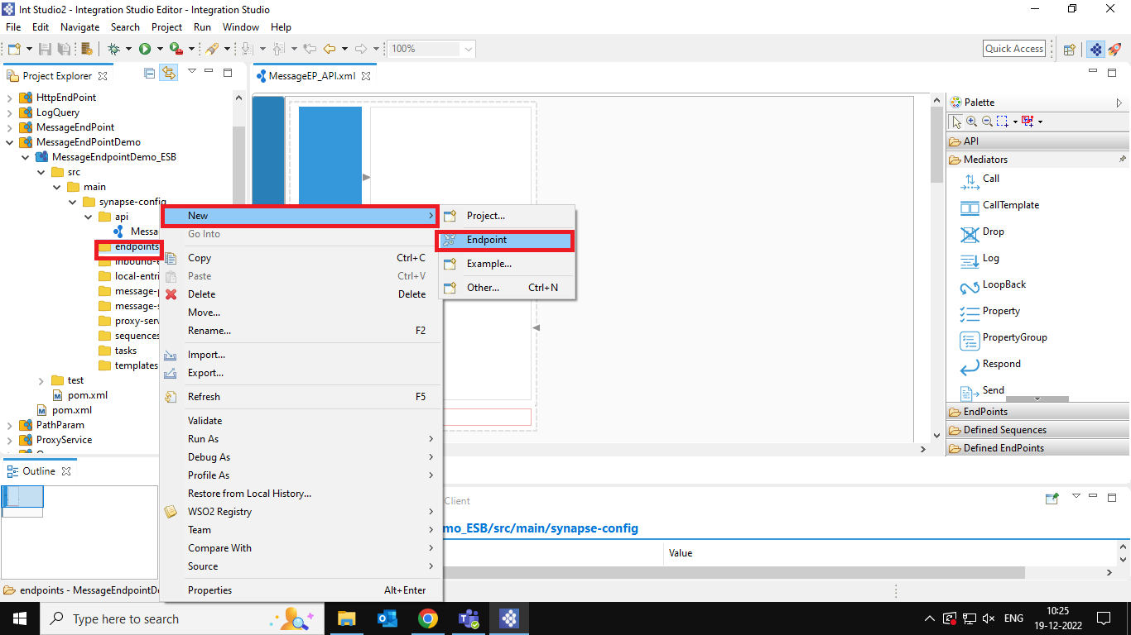

>>Click on Next.

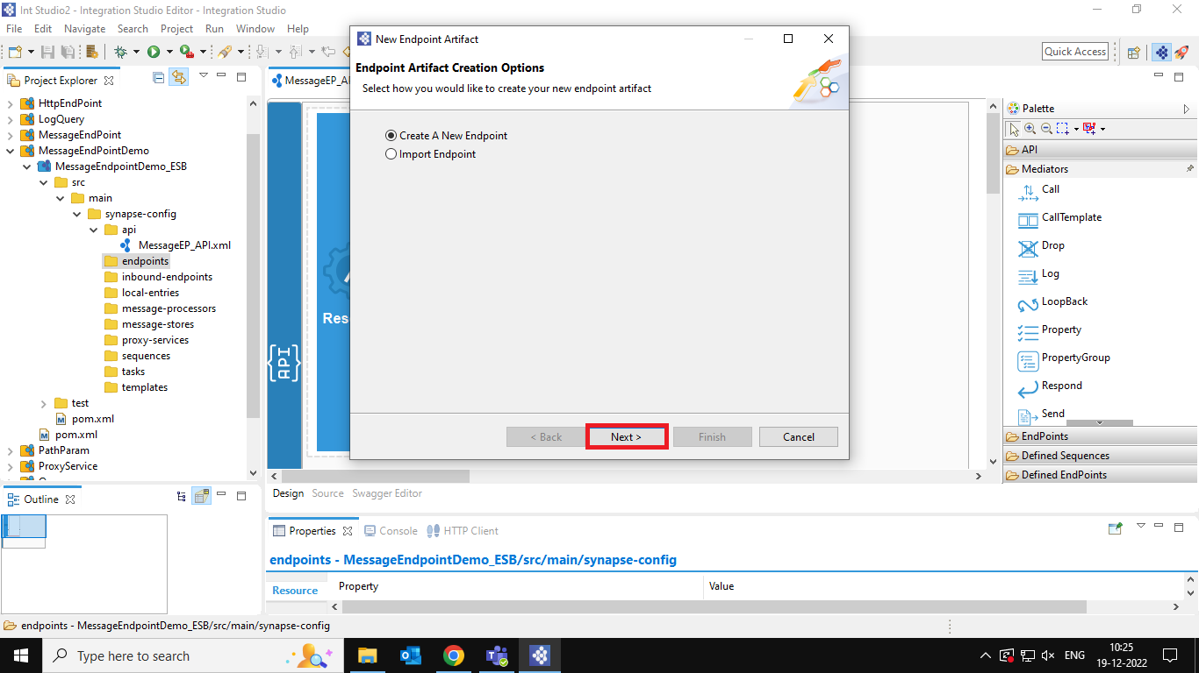

>>Enter the End Point Name

>>Endpoint Type = Address End Point.

>>Them click On Finish.

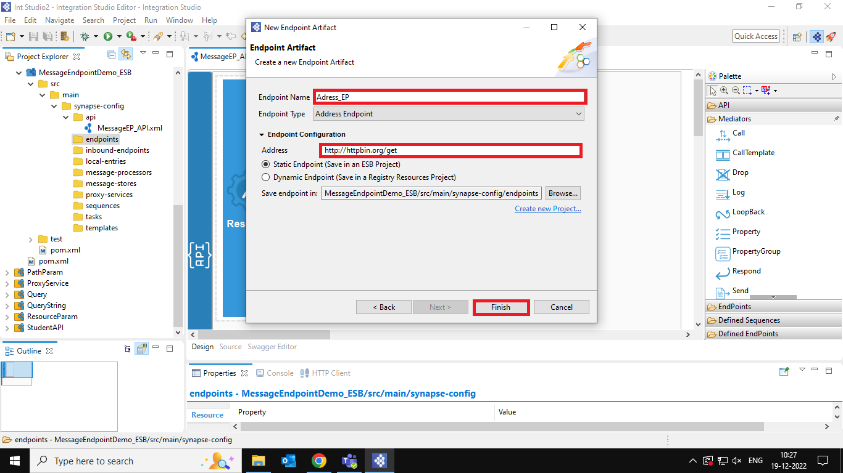

>>Click on the End Point in the endpoints folder.

>>Type the URL (end point destination) and save.

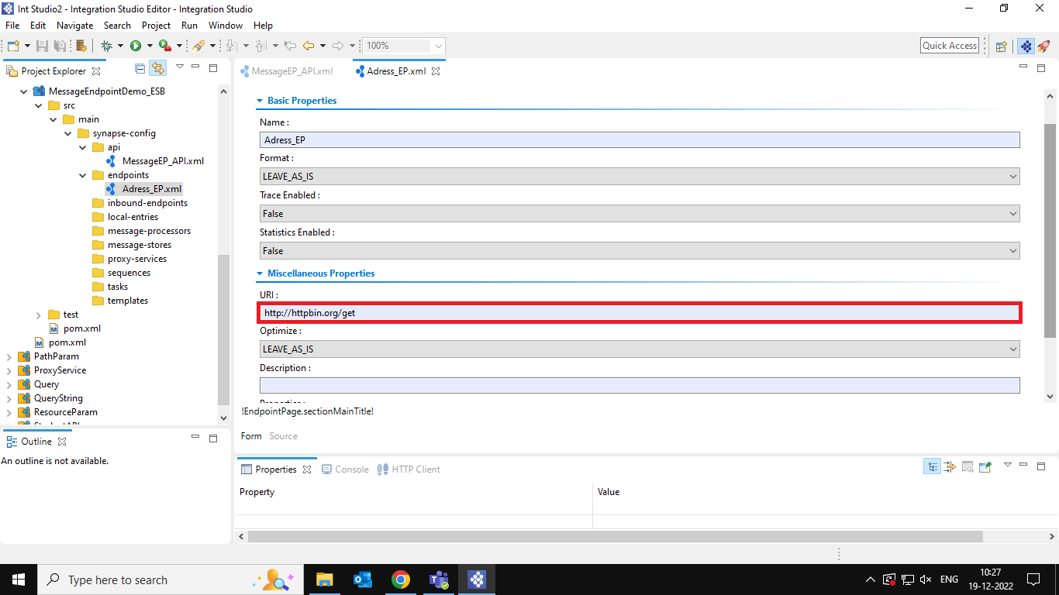

**Step 4:** Now Drag the defined point and place it inside the send mediator .

>>Click on defined end points.

>>Drag and drop the end point.

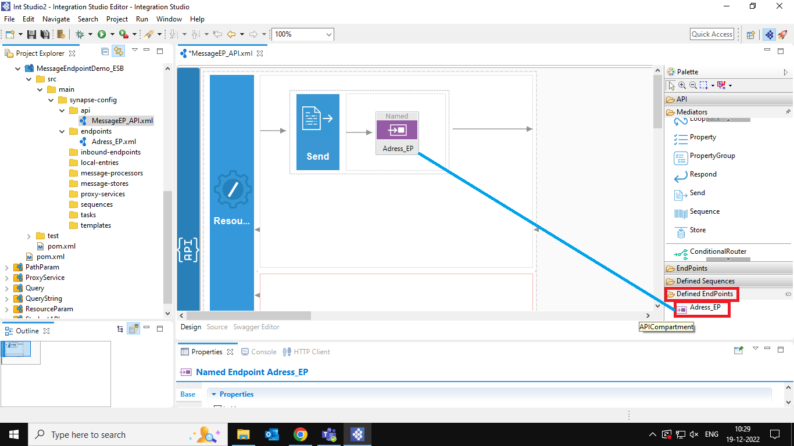

**Step 5**: Now drag the Send mediator and drop in the out sequence.

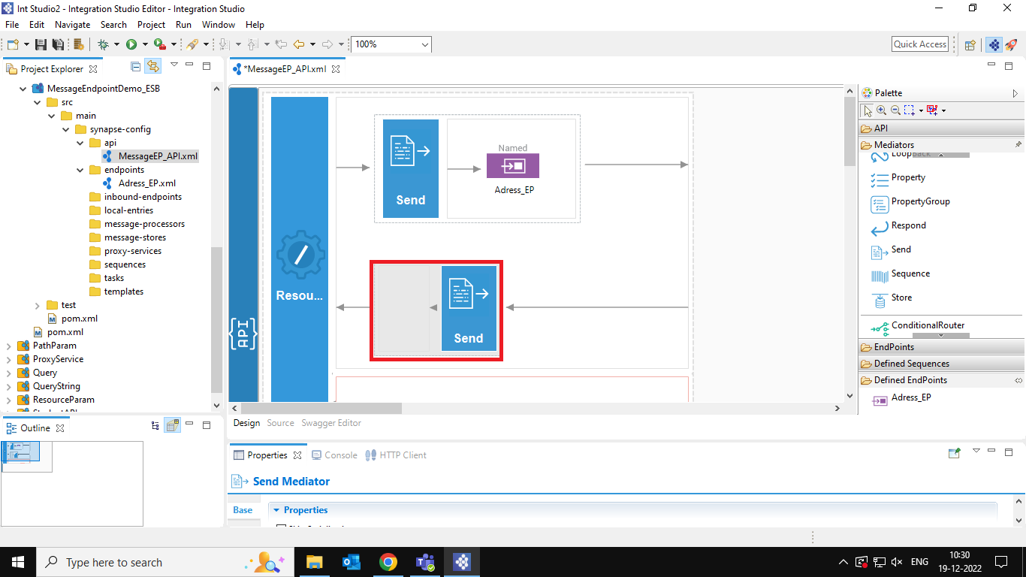

Now the design part is completed. So, we must create a car to deploy our project.

**Step 6:** Right click on the Project select new 🡪 composite exporter.

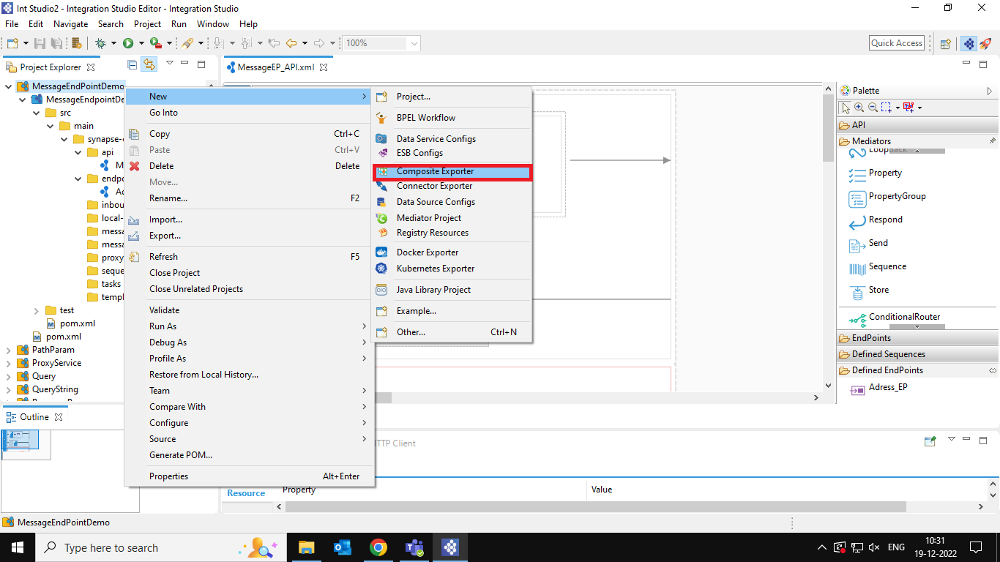

**Step 7:** Give a module name and select the dependency ESB layer of that project.

**Step 8:** Click on finish.

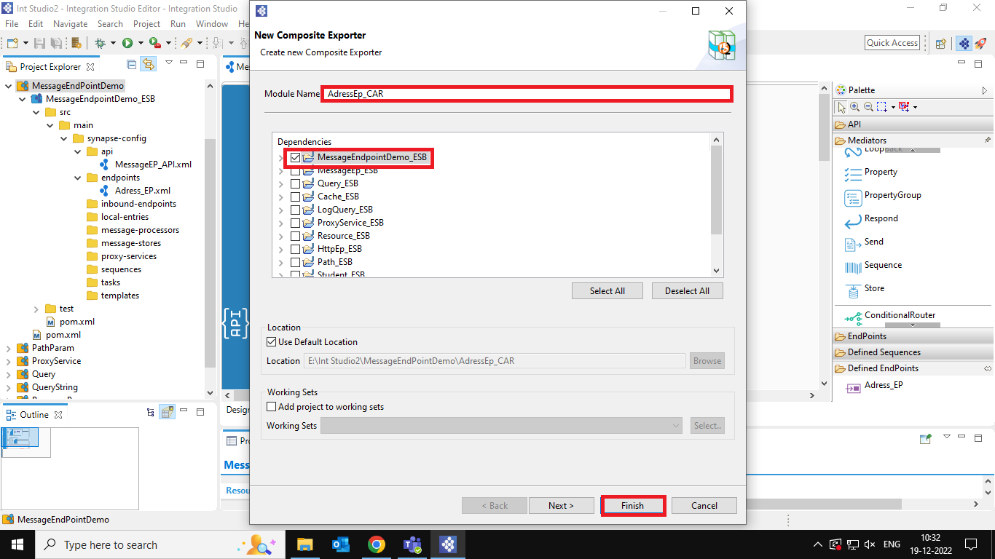

**Step 9:** Deploy the CAR file to server. Right click on the server click on Add and remove Option.

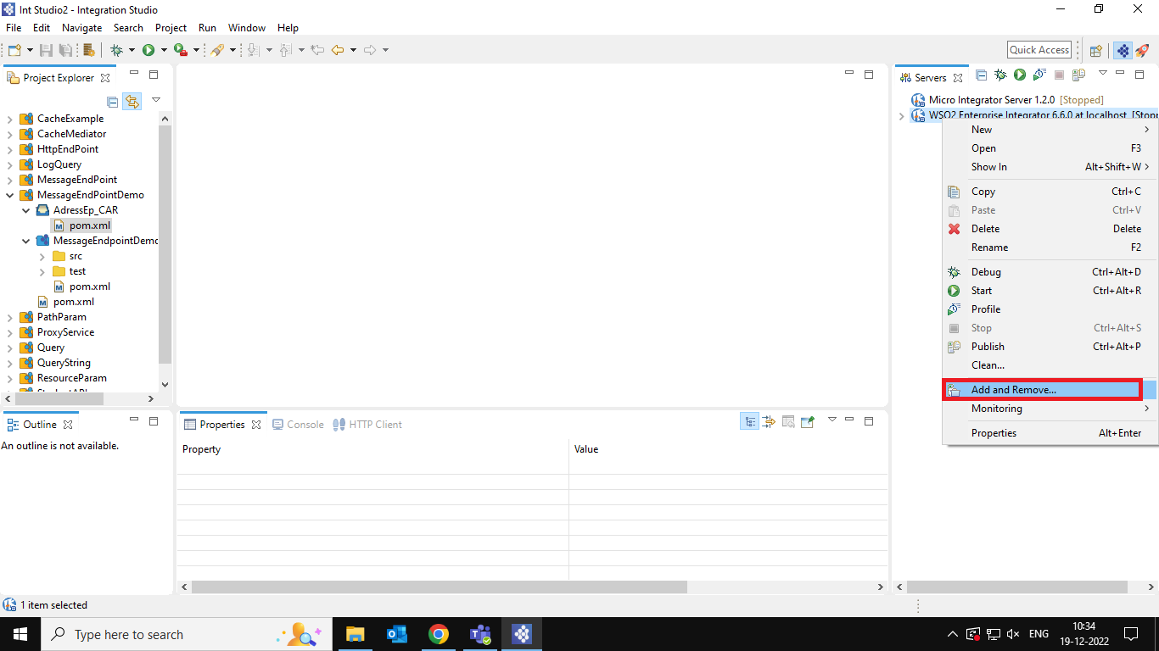

**Step 9:** select the CAR file and add to the server and click on finish.

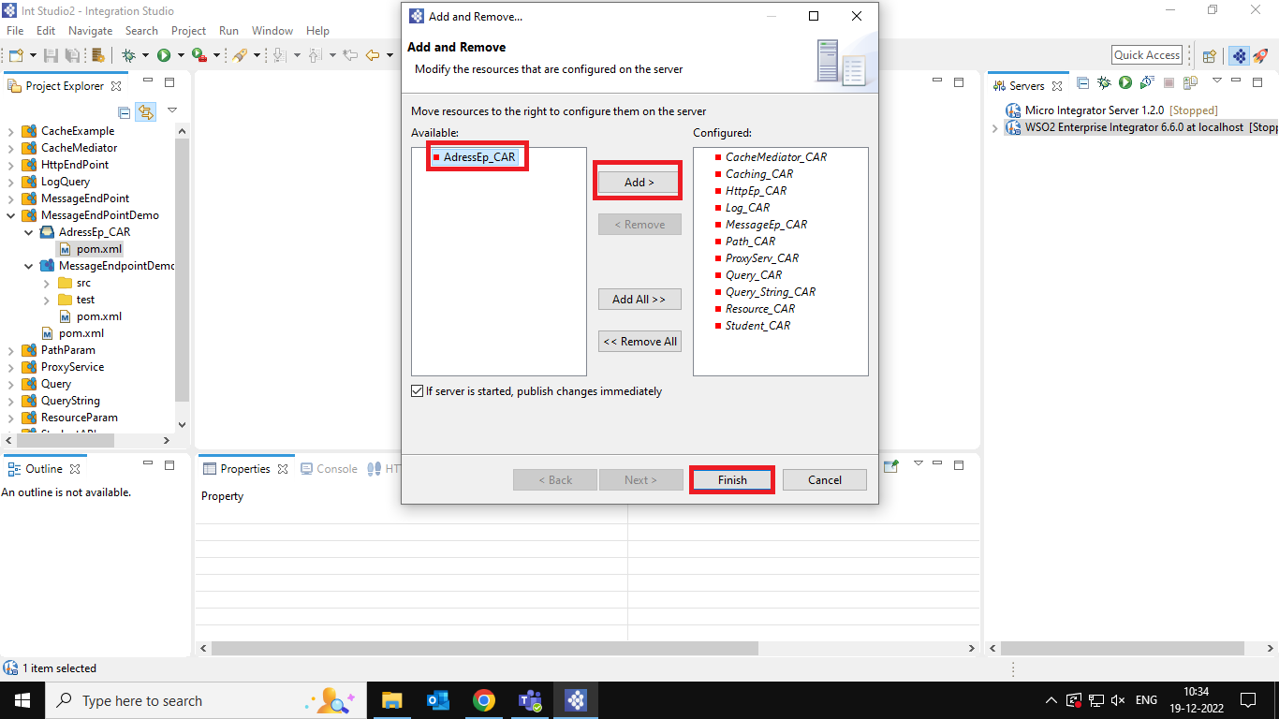

Now the CAR file is Deployed to the server.

**Step 10:** Open the WSO2 Enterprise Integrator in the Web Browser.

**Step 11:** Click on the API

**Step 12:** Select the path of the CAR file you deployed.

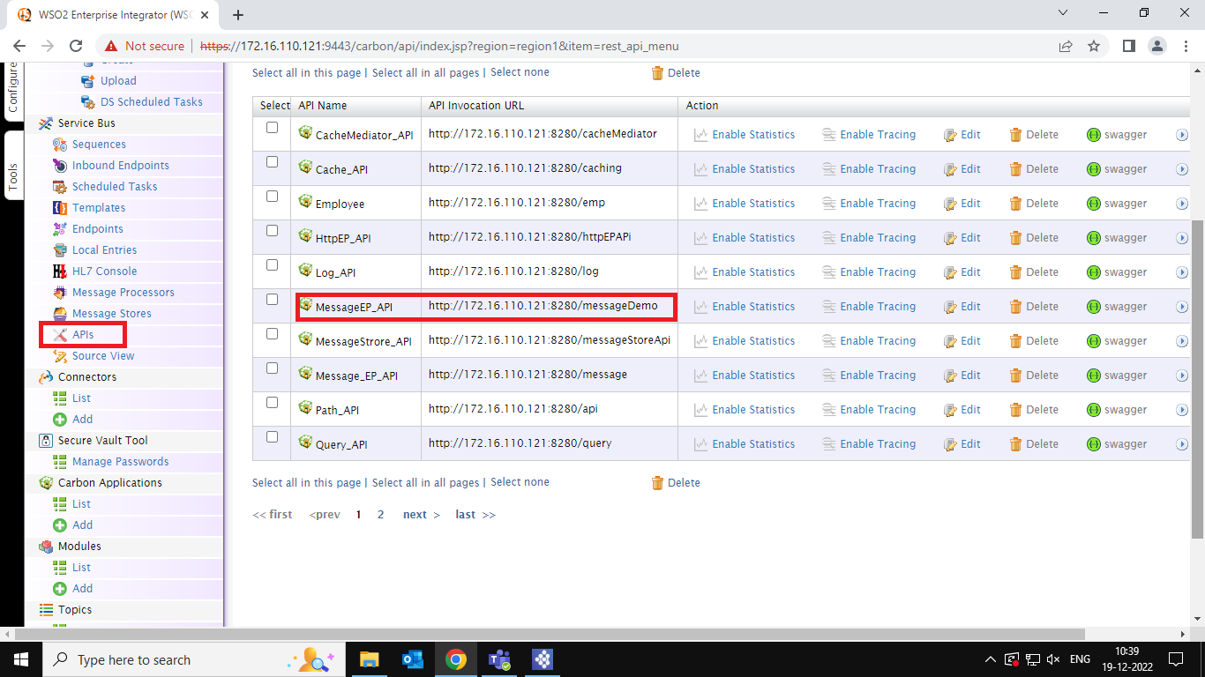

**Step 13:** Paste the URL in the web browser and press enter.

……………………………………………………………………………………………………………………………………………………………………

After Successful execution of the End Point, you may be redirected to the page like below.

# Successfully Created the Address End Point.